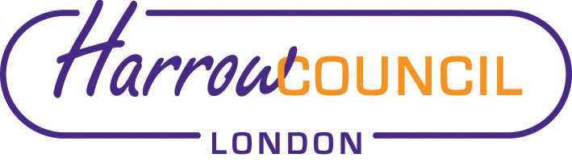
Harrow SACRE Meeting

Thursday 10 December 2020 at 7.30 p.m.
To be held via video conferencing

Enquiries & apologies to:
Vivian Wright, Clerk to SACRE
vmwright@waitrose.com

Adviser to SACRE: Lesley Prior

Agenda
- Welcome:

- Apologies for absence:

- Minutes of the last meeting on 29 September 2020 (attached): to agree the minutes as a true record.

- Matters arising from the minutes

- Local and National Updates including EGM

- Collective Worship Policy (attached)

- Determinations

- Vaughan Determination

- Priorities for the year ahead

- Annual report (Chair’s report attached)

- News from Faith Groups relating to schools

- Any Other Business

- Future Dates

- Tuesday 9 March 2021

